### Southern New Hampshire University

### CS 319 – UI/UX Design and Development

### Module 4-2: Project One

Kenneth Wilkerson

### Dr. Vivian Lyon

August 2, 2024

**Digital Wireframe**

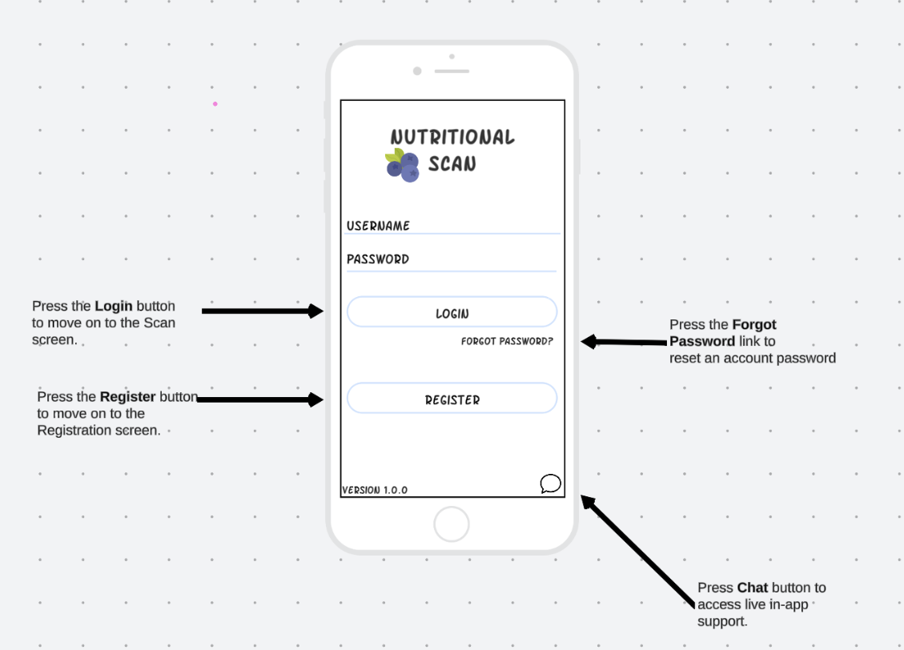

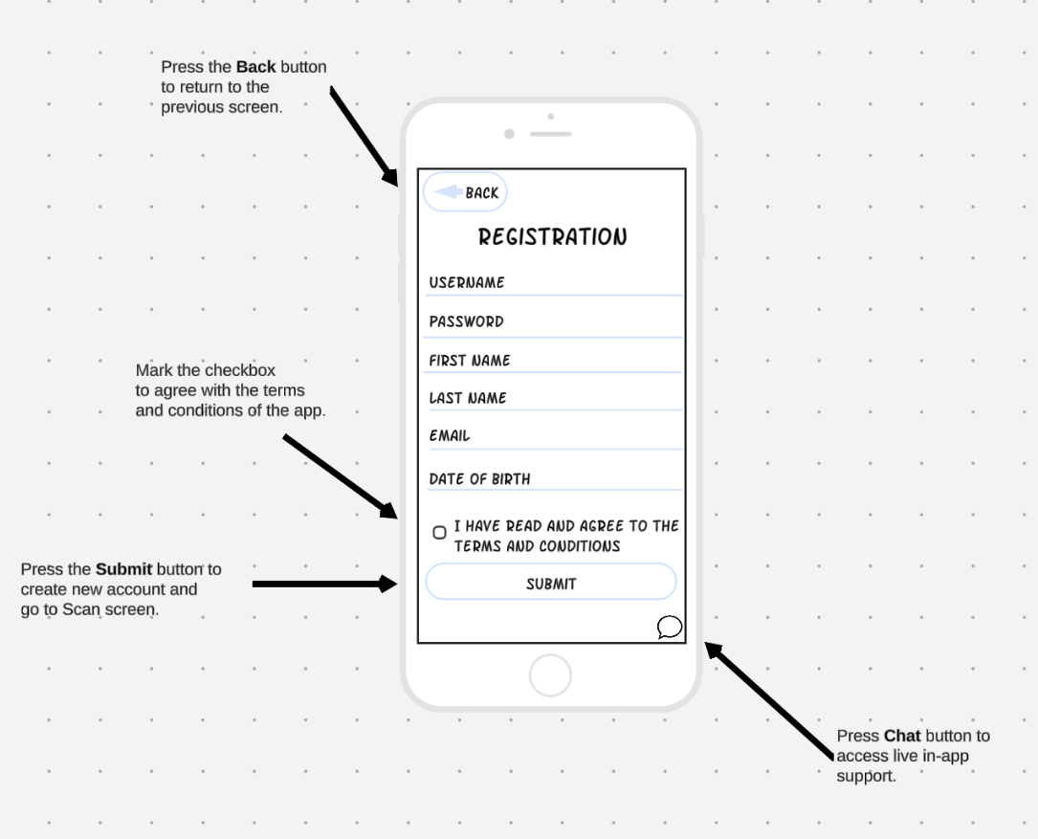

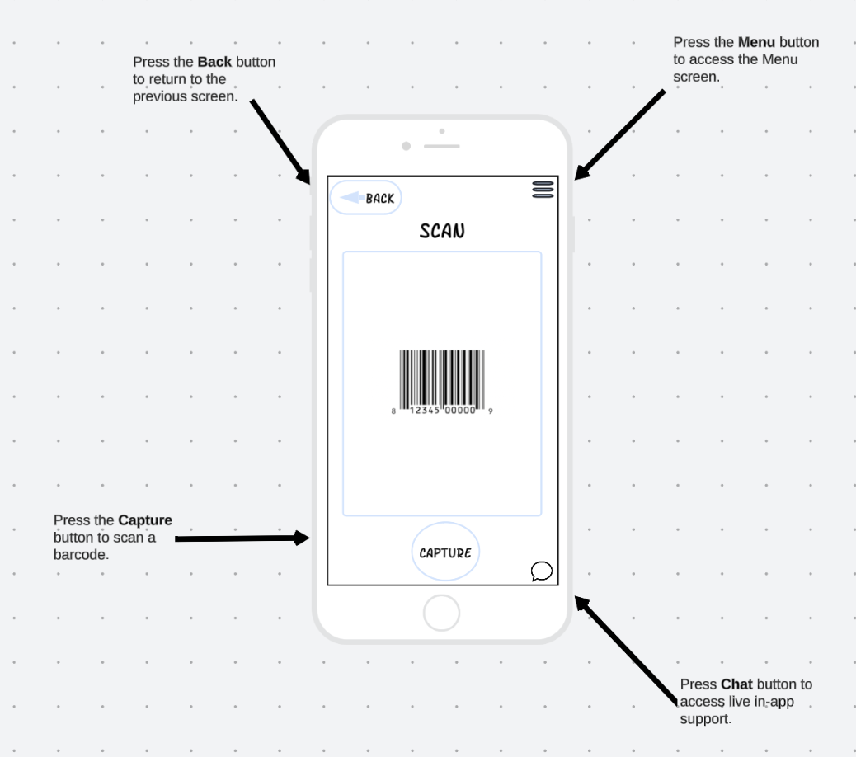

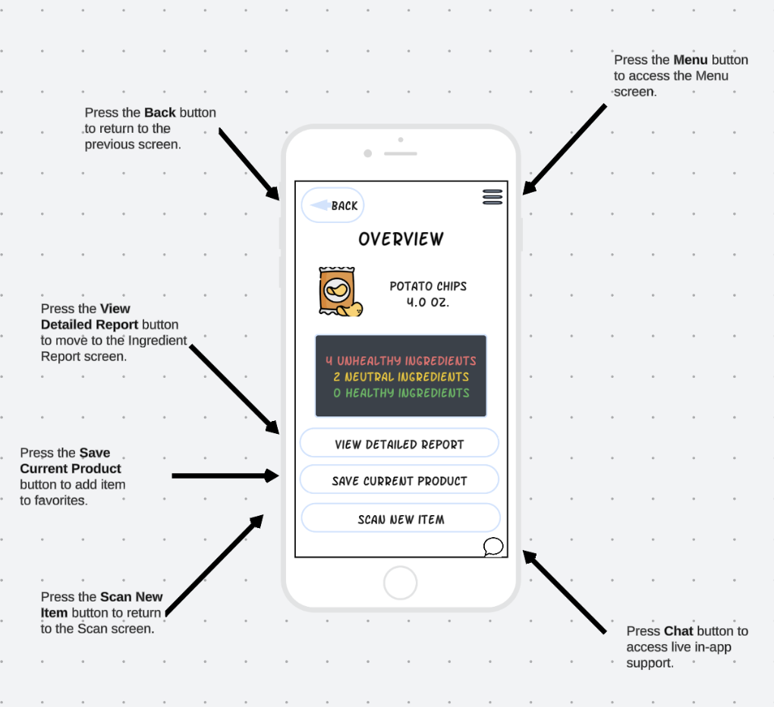

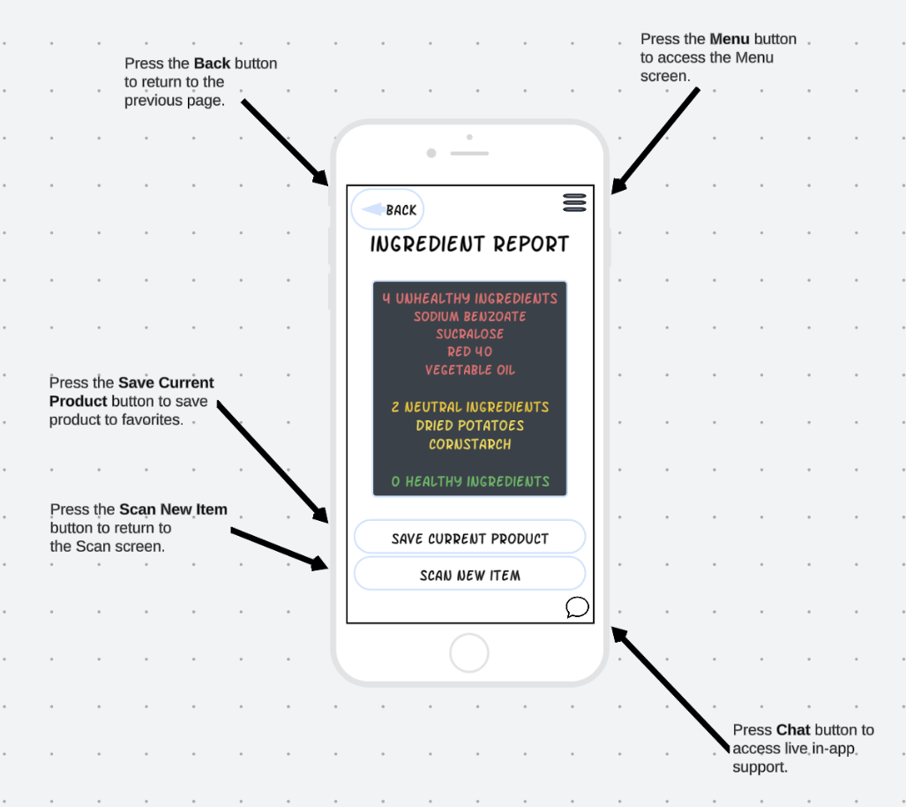

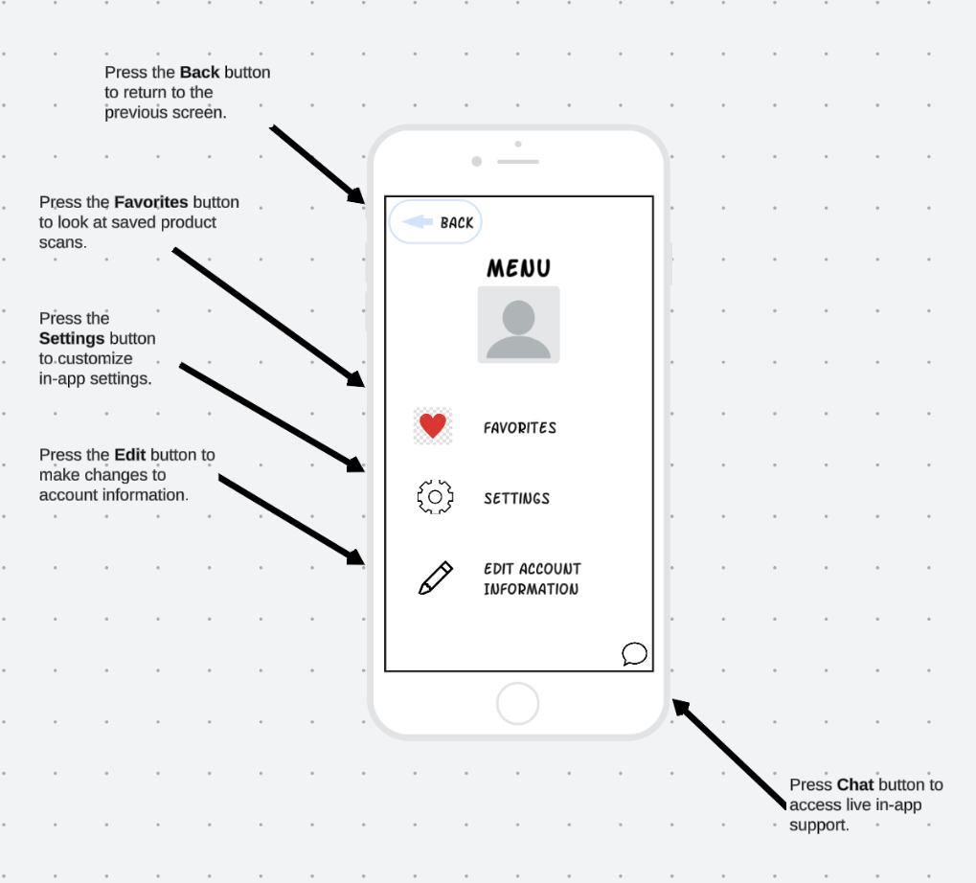

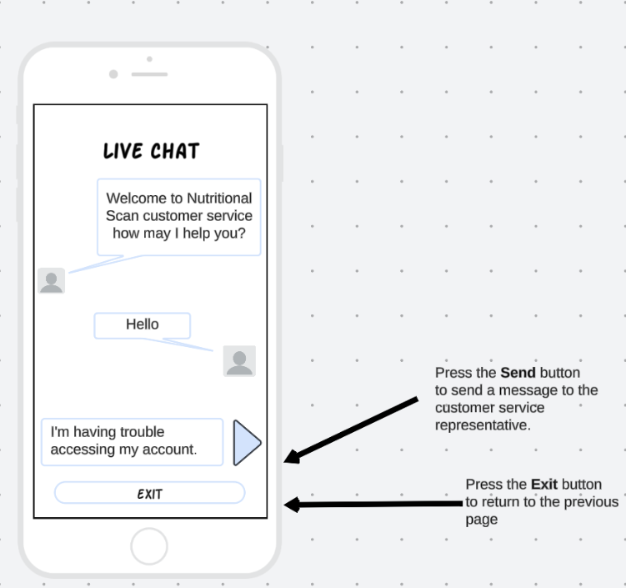

**Client Communication and Recommendations**

**Rationale**

The purpose of the Nutritional Scan login screen is to welcome all users and introduce the brand name of the app. All users will need verify that they have an account on the app by entering the proper username and password. Once these users have been authenticated, they will be able to access the core functionality of the app. Specifically, they will be able to access the Scan screen in order to scan the barcode of food items for ingredient reports. As an account recovery feature, users who forgot their password will be able to click on the Forgot Password link in order to reset their password. Furthermore, the login screen gives new users a chance to create an account so that they can authenticate themselves for future usage. Lastly, as a troubleshooting feature, there is an in-app chat icon to address and questions or issues that users encounter on any screen of the app. Authentication and account recovery benefits the user because they protect the personal information of the user. This screen allows users to quickly move on to the main features of the app. In-app chat benefits the user because they are able to receive prompt assistance when they encounter any issues or have questions. This allows the user to troubleshoot and still be able to use the app in the setting they are in. Overall, this page offers a secure and supportive experience for the user regardless of if they are new or returning users.

Additionally, the purpose of the Registration screen is for new users to enter personal information for account security reasons. All users will need to agree to the terms and conditions of the app prior to usage. If there are any account creation issues, the in-app chat option is available for troubleshooting. The Registration screen benefits the user by implementing security measures. It also creates a user-friendly onboarding experience which helps create a good first impression. Additionally, in-app chat support is continuously offered to the user ensure the user has a positive experience throughout the app. Furthermore, the Scan screen is one of the core elements of the app. The Scan screen is for users to scan the barcode of a food product to retrieve ingredient information. The app integrates with the user’s mobile phone camera in order to facilitate this function. The screen provides feedback in the form of a beeping sound and vibration to confirm a successful scan. Users are able to access in-app chat if there are issues with barcode scanning. This screen benefits the user because scanning barcodes is more efficient than manually entering the numbers associated with a barcode. It also allows users to use a camera that they are already familiar with to scan products which makes the app more intuitive and user-friendly. The beeping sound and vibration associated with a successful scan makes it clear that a product was successfully scanned which avoids confusion in the user. Users also have access to quick troubleshooting with in-app chat so that they can quickly return to scanning. The overall user experience is improved by having quick and intuitive functionality.

The purpose of the Overview screen is to provide a comprehensive view of the number of ingredients that fall into each color-coded category. Users are able to see the product information of the product they scanned. They also have the option of viewing a detailed report that outlines the ingredients that fall into each category. Additionally, users are able to save a product to their favorites. Lastly, if the general overview of a product is satisfactory, users are able to continue scanning other products. In-app chat is available in case there are questions about the product scanned or the general ingredient information. This screen design benefits the customer because they receive a summary of essential information which saves time and allows them to continue to scan other items. Users have the option to view a more detailed report which deepens their understanding of healthy and unhealthy ingredients. Saving a product to favorites allows a user to save frequently scanned items which makes the app more convenient for the user. Having in-app chat is crucial to ensuring the product and ingredient information is accurate. In-app chat ensures a frustration free experience in case there are any errors in the overview. Moreover, the Ingredient Report screen is for users who would like to enhance their knowledge of ingredient quality. Users are able to see a list of specific ingredients that fall within each color coded ranking. This page is scrollable so that users can view all ingredients in full. Users still have the option to save the food product to favorites based on the detailed report. They can also return to scanning new items when they are ready. Lastly, in-app support remains available in case there are questions or issues about the ingredient report.

The Menu screen allows the user to customize the app based on their preferences. First, there is a Favorites list which contains the most frequently scanned items. There is also a setting option where users can access a list of accessibility options such as voice navigation, text-to-speech, haptic feedback and light and dark mode. Users can also edit their account information when they would like to change the username, password or email address associated with their account. In-app chat support is also available to the user in case there is an issue with any of the customization features available. The Menu screen design benefits the user because there are several customization options available. The Favorites list is useful for quick access. Voice navigation allows for hands-free usage. Text-to-speech is useful for users with visual impairments. Haptic feedback makes the app more intuitive and user-friendly by confirming actions taken by the user. Light and dark mode is useful to make sure the app is readable in a variety of environments. Also, allowing users to edit their account information ensures that their account is up to date and secure. In-app chat support helps to make sure that all customization features are working so that the app meets the needs of all users. Lastly, the Live Chat screen is available for users who have opted to access in-app chat support for any questions or issues that need to be addressed. Users are able to send messages to a live representative and get quick responses so that they can return to using other core features of the app. Having in-app chat support layered throughout the app ensures that users will have consistent access to help which enhances the overall user experience.

There are many innovative solutions that were incorporated into the apps design to increase the apps usability. I added accessibility features so that users with disabilities can engage with the app. Voice navigation was designed to allow for hands-free usage. Text-to-speech was added to assist users with visual impairments hear the ingredient reports. Haptic feedback was added to help users with visual or auditory impairments. Light and dark mode was also added so that the app is readable in different environments. Also, choosing to use a simple design allows the user to focus on the main features of the app. I chose white and blue as my primary and secondary colors. This allowed color to have a more significant impact when it was used to rank the healthiness of ingredients. My primary and secondary color choice helped create a calm and professional look which helped achieve the goal of creating a pleasant experience for users who were looking for healthy food items.

My prior research on color and sounds helped me prioritize the user experience while implementing my designs. Color and sound add valuable benefits to the app and help guide the user as they are engaging with the app. It was important for me avoid overusing color and sound to ensure that their meaning was clear and intuitive for users.

Designing accessibility features according to the best practices in UI design was also crucial for ensuring that all users can interact with the app. Also, I want users to remember the brand by creating an engaging and useful app. If the app improves users’ lives, they are more likely to return and use it again.

**Digital Watch Adaptations**

The adaptations that are made for a digital watch will need to be made primarily due to the smaller screen size. A more simplified UI will be needed to display only essential information. For example, there will only be an Overview screen after scanning a barcode. Users will still be able to understand how many healthy, neutral or unhealthy ingredients there are. However, removing the Ingredient Report screen will allow for a more streamlined experience. Furthermore, there will not be access to in app chat on the digital watch version because there is not enough screen space. On the Scan screen, users will have the option for manual barcode entry or voice-to-text barcode entry, since digital watches have limited camera capacity and screen space. For navigation, there will still be scroll and touch activation. Additionally, there will be swipe functionality added to move between screens. Swiping toward the left will be used to return to the previous screen. There will be more intuitive icons to replace buttons. For example, instead of the Capture button, there will be a barcode icon to submit the barcode information that has been entered manually or though voice-to-text. Accessibility features will remain on the digital watch version of the app such as voice navigation, text to speech and haptic feedback to ensure inclusivity.

These adaptations offer priority content with a logical series of actions by

focusing on essential information and streamlining the user experience. Focusing on the Overview screen ensures that users can quickly view the number of ingredients that falls within each ranking which fulfills the mission of the app. These adaptations also make sense and offer value that matches the user’s experience on the mobile device.

Switching to manual and text-to-speech barcode entry helps adapt to the smaller screen space and limited camera capacity. These adaptations follow the best practices for wearables. Overall, the design is holistic by implementing a simplified UI. The design is glanceable by focusing on the Overview screen and not including the Ingredient Report screen. The design is easy to interact with because there will be scroll and touch activation as well as swipe functionality. Also, replacing buttons with intuitive icons will help ensure the ease of interaction. The design is time-saving because text-to-speech barcode entry is quicker than manual barcode entry. These features also make the app more accessible.

**Touch-Based Kiosk Adaptations**

The adaptations made for a touch-based kiosk will be primarily due to a larger screen size. First, the app will be designed to be usable in landscape and portrait orientations so that they work on all kiosk shapes. I will add tutorial features throughout the app to guide users. Additionally, the Ingredient Report screen will be improved. I will add an explanation of why products are ranked in each category to educate users. Product recommendations will be added for items with ingredients that are skewed towards the unhealthy category. This will help users find alternatives to choices they originally made. I also want to add large text and buttons. For touch feedback, the selected area will be highlighted in orange to enhance navigation. I also want buttons to change colors when pressed so that users get feedback for their actions. Zoom features will also be added. I want to add a zoom-in feature by moving two fingers apart and a zoom-out feature by pressing two fingers together. I also want to keep most of the accessibility features such as voice navigation, text-to-speech and light and dark mode.

These design adaptations offer priority content with a logical series of actions by being functional in landscape and portrait mode. The tutorial features will guide user interaction throughout the app which enhances its overall user-friendliness. These adaptations make sense and offer value that matches the user’s experience on the mobile device.Increasing the size of text and buttons makes the app more useable. Highlighting the area of focus and changing the color of buttons when pressed provides valuable feedback. The zoom-in and zoom-out features, using two fingers, allows users to adjust the screen based on their needs. These adaptations follow best practices for large screens. Navigation is easy because text and buttons will be larger. Highlighting the area of focus in orange makes it easy for users to see their selection. Changing the color of buttons provides useful feedback by confirming user actions. The zoom features follow touch screen guidelines and enhance the user experience. Additionally, the chosen accessibility features ensures the app remains inclusive.